IT Employee Lifecycle Automation System

Customer Problem Statements & System Requirements
Stephen Torrijas

Customer Problem Statement
Organizations of all sizes rely on IT departments to provision and deprovision user accounts throughout the employee lifecycle. When a new employee joins, IT administrators must create Active Directory accounts, assign appropriate security groups based on department and role, and grant access to necessary resources. This process typically begins when IT receives notification via email or helpdesk ticket, often the day of or after the employee starts resulting in delayed access and lost productivity during critical onboarding periods.
The offboarding process presents even greater challenges. When employees depart, IT frequently receives late or incomplete notifications, leaving former employees with active credentials and access to sensitive company resources. These orphaned accounts create significant security vulnerabilities and compliance risks. Additionally, manual provisioning leads to inconsistency: different IT staff may assign different permissions to employees in identical roles, creating access disparities and audit failures.
An automated system is needed that continuously monitors the HR system for personnel changes and automatically executes corresponding account actions such as creating accounts for new hires with role-appropriate permissions and promptly disabling accounts for departing employees. The system should provide a centralized dashboard for oversight, manual intervention capabilities, and comprehensive audit logging to ensure compliance.

Glossary of Terms
Term | Definition
Employee Lifecycle | The stages an employee progresses through within an organization: onboarding (joining), active employment, role changes, and offboarding (departure).
Provisioning | The process of creating user accounts and assigning appropriate access permissions when an employee joins the organization.
Deprovisioning | The process of disabling or removing user accounts and revoking access when an employee leaves the organization.
Orphaned Account | A user account that remains active after an employee has left the organization, creating a security vulnerability.
Role-Permission Mapping | A configuration that defines which security groups and access levels are automatically assigned based on an employee's department and job title.
Polling Interval | The frequency at which the system checks the HR database for changes in employee status.
Audit Log | A chronological record of all account lifecycle events, including who performed actions and when.

System Requirements

Functional Requirements
No. | Priority Weight | Description
REQ-1 | High | The system shall automatically detect new employees added to the HR management system.
REQ-2 | High | The system shall automatically create Active Directory accounts for new employees.
REQ-3 | High | The system shall assign security groups based on configured department and role mappings.
REQ-4 | High | The system shall automatically detect employee terminations in the HR management system.
REQ-5 | High | The system shall automatically disable Active Directory accounts for terminated employees.
REQ-6 | High | IT administrators shall be able to configure mappings between departments/roles and Active Directory security groups.
REQ-7 | High | IT administrators shall be able to manually approve, modify, or override automated account actions.
REQ-8 | Medium | IT administrators shall be able to configure the polling interval for HR system synchronization.
REQ-9 | High | The system shall maintain comprehensive audit logs of all account lifecycle events.
REQ-10 | Medium | IT administrators shall be able to generate compliance reports for specified date ranges.
REQ-11 | Medium | HR personnel shall be able to view the provisioning status of newly entered employees.
REQ-12 | Low | HR personnel shall be able to flag high-priority onboarding requests for expedited processing.
REQ-13 | Medium | Department managers shall be able to view account status for their direct reports.
REQ-14 | Low | Department managers shall be able to submit requests for additional access or permissions for team members.
REQ-15 | Medium | The system shall send notifications to stakeholders when account actions are completed or require attention.

Nonfunctional Requirements (FURPS)
No. | Category | Priority Weight | Description
NFR-1 | Functionality | High | The system shall integrate with OrangeHRM via REST API.
NFR-2 | Functionality | High | The system shall communicate with Active Directory via LDAP or LDAPS protocol.
NFR-3 | Usability | Medium | The dashboard shall display pending, completed, and failed tasks in a clear visual layout with status indicators.
NFR-4 | Usability | Medium | The system shall provide intuitive navigation between different user role views (IT Admin, HR, Manager).
NFR-5 | Reliability | High | The system shall retry failed operations up to 3 times before marking them as failed.
NFR-6 | Reliability | High | The system shall continue operating normally if individual account operations fail (graceful degradation).
NFR-7 | Performance | Medium | The system shall detect and process new employee changes within 5 minutes of the configured polling interval.
NFR-8 | Performance | Medium | Account creation and disabling operations shall complete within 30 seconds.
NFR-9 | Supportability | Medium | The system shall log all errors with sufficient detail (timestamps, error codes, context) for troubleshooting.
NFR-10 | Supportability | Low | The system shall support configuration changes (mappings, intervals, notifications) without code modifications.

User Interface Requirements

UI-1: Main Dashboard (High Priority)
Description: The main dashboard provides IT administrators with a glance of all account lifecycle activities.
Layout: Three-column layout with left sidebar navigation, main content area, and right statistics panel.
Components:
• Top bar: System name, current user information, logout button
• Left sidebar: Navigation links including Dashboard, Mappings, Audit Logs, Reports, and Settings
• Main content area: Tabbed interface with "Pending Tasks," "In Progress," and "Completed/Failed" sections
• Task cards: Each task displays employee name, action type (Onboard/Offboard), department, timestamp, and status badge
• Right panel: Statistics cards showing counts for Pending, Completed Today, and Failed tasks
• Action buttons: View Details, Approve, and Reject buttons on each pending task
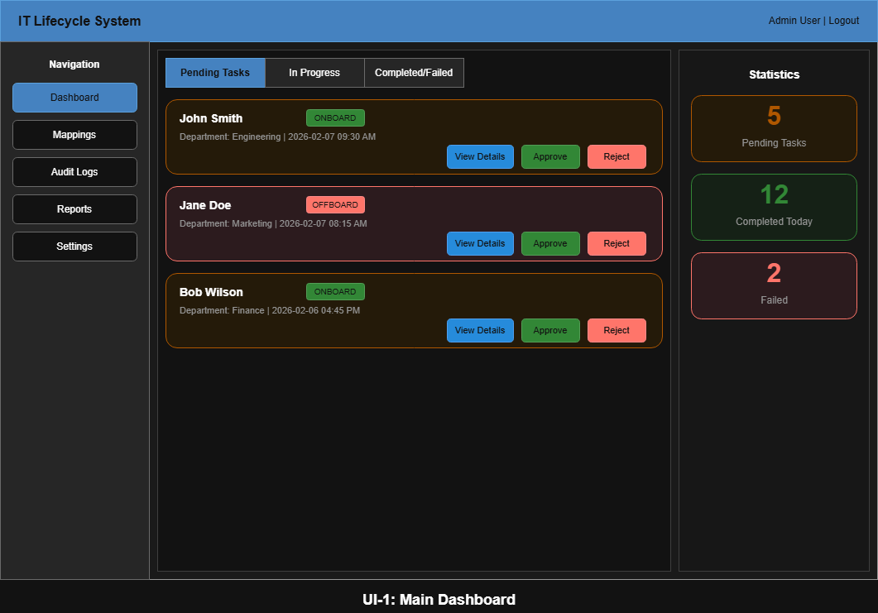

UI-2: Department-to-Group Mapping Configuration (High Priority)
Description: This interface allows IT administrators to configure which Active Directory security groups are automatically assigned based on department and role.
Layout: Two-panel master-detail interface.
Components:
• Left panel: Searchable list of all departments imported from OrangeHRM
• Right panel: When a department is selected, displays currently assigned AD security groups
• Add Group button: Opens a dropdown of available AD groups to add
• Remove button (X): Appears next to each assigned group for removal
• Role sub-mappings: Expandable sections under each department for role-specific group assignments
• Save Changes button: Located at bottom to persist configuration changes
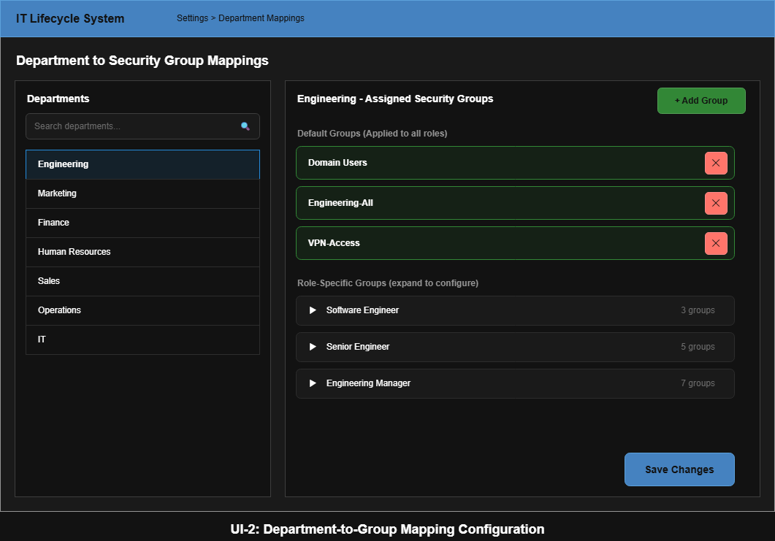

UI-3: Task Detail View (High Priority)
Description: A detailed view of a specific onboarding or offboarding task, allowing administrators to review and take action.
Layout: Modal popup or dedicated full-page view.
Components:
• Header: Employee full name with action type badge (Onboard/Offboard)
• Employee Info section: Name, Employee ID, Department, Job Title, Start Date or Termination Date
• Proposed Actions section: List of AD groups to be assigned or removed, account actions to be taken
• Override section: Checkboxes allowing administrators to add or remove additional groups from the automated selection
• Action buttons: Approve (execute actions), Reject with Reason (cancel with documentation), Save for Later
• History section: Timeline of previous account actions for this employee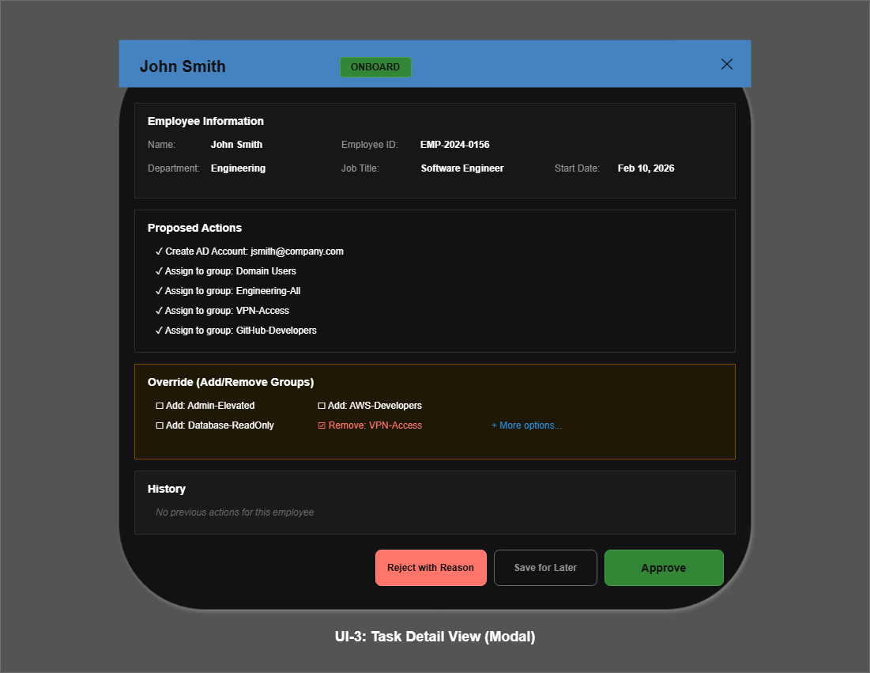

UI-4: Audit Log Viewer (Medium Priority)
Description: A searchable, filterable log of all account lifecycle events for compliance and troubleshooting purposes.
Layout: Full-width data table with filter controls above.
Components:
• Filter bar: Date range picker, Action Type dropdown (All, Create, Disable, Modify), Performed By dropdown, Search box
• Table columns: Timestamp, Action Type, Target Employee, Performed By (user or "System"), Status, Details link
• Expandable rows: Clicking a row expands to show full action details and any error messages
• Export button: Located in top right corner, exports to CSV or PDF format
• Pagination controls: Page navigation at bottom of table
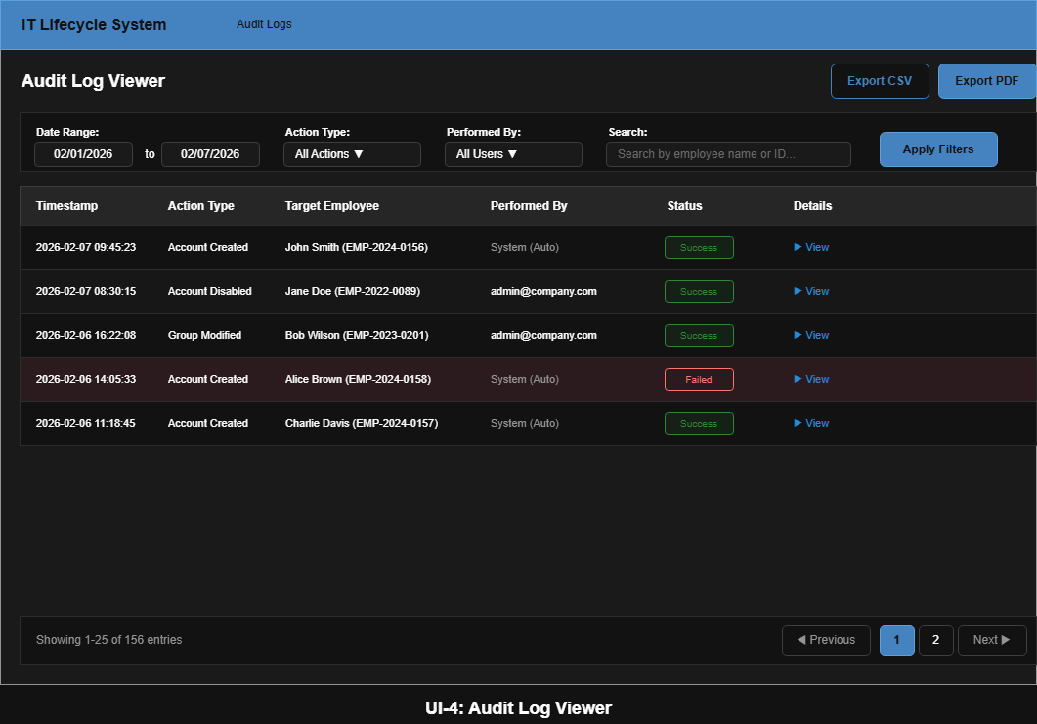

UI-5: Report Generation (Medium Priority)
Description: Interface for generating and exporting compliance and activity reports.
Layout: Form-based interface with preview area below.
Components:
• Report Type dropdown: Options include Compliance Report, Activity Summary, and Failed Actions Report
• Date Range selectors: Start date and end date pickers
• Department Filter: Multi-select dropdown to filter by specific departments
• Generate Preview button: Creates a preview of the report
• Preview area: Displays report summary with key metrics and data tables
• Export buttons: Download PDF, Download CSV, and Email Report options
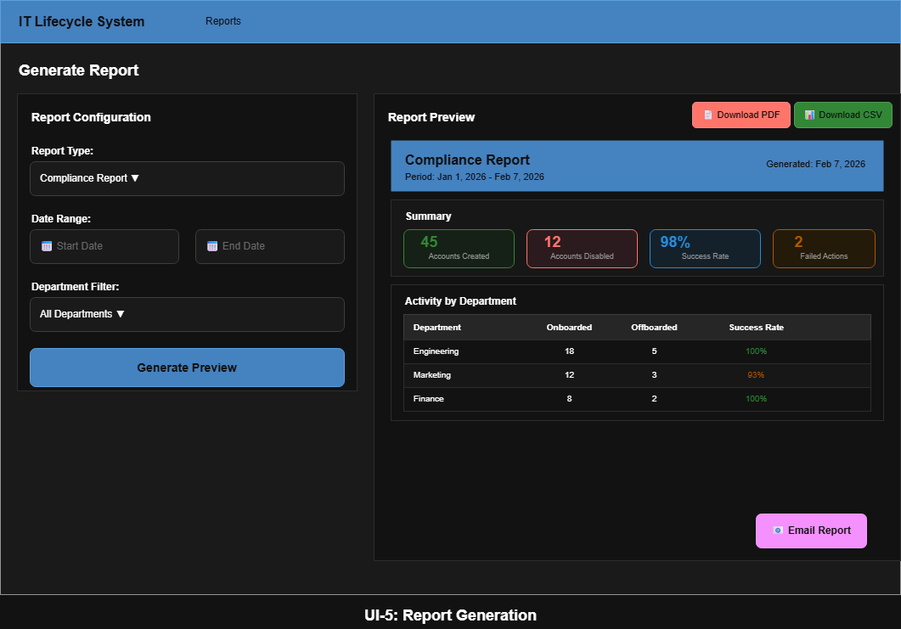

UI-6: Employee Search and Status Lookup (Low Priority)
Description: Allows authorized users to search for employees and view their current account status.
Layout: Search bar with results table below.
Components:
• Search bar: Large text input for searching by employee name, employee ID, or email address
• Results table: Columns for Name, Employee ID, Department, Account Status, and Last Action Date
• Row interaction: Clicking a row opens the Employee Detail view
• Status indicators: Visual badges showing Active (green), Disabled (red), or Pending (yellow) status
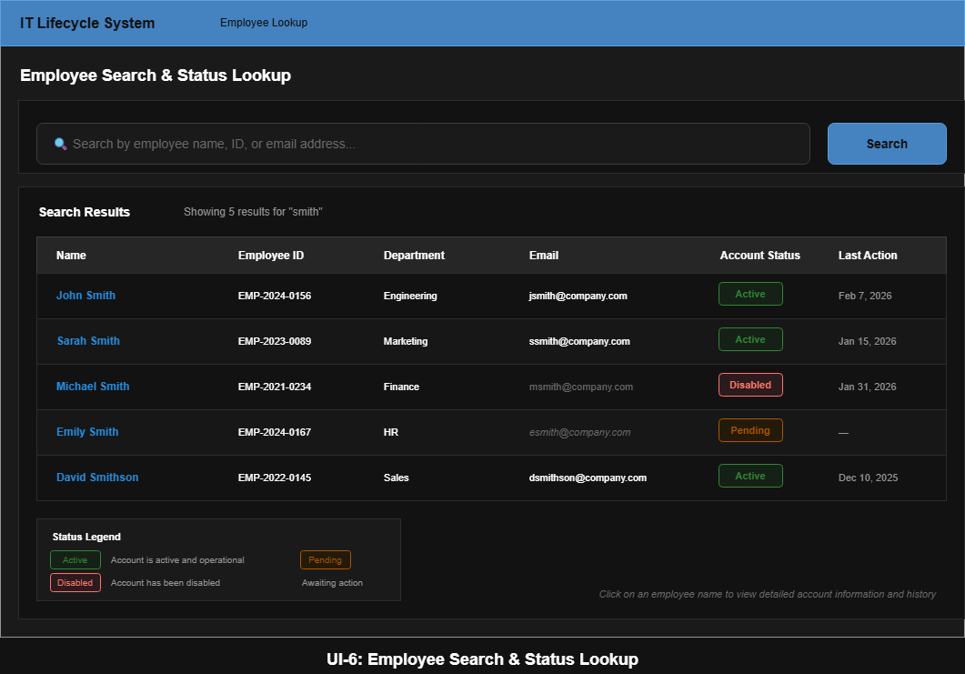

Plan of Work
Week | Status | Milestones
1-2 | Complete | Project proposal submitted and approved
3-4 | In Progress | System requirements documentation; environment setup planning
5-7 | Pending | Deploy OrangeHRM and Windows Server VM with Active Directory; establish MySQL database schema; build initial dashboard UI; connect frontend to backend
8 | Pending | Mid-term milestone: Core onboarding automation complete; testing and demonstration recording
9-11 | Pending | Implement offboarding automation; notification system for stakeholders; audit logging functionality
12-14 | Pending | Build reporting and analytics features; refine approval workflows; write automated test cases
15 | Pending | Final integration testing; record final demonstration; complete project documentation

Current Progress
- Project proposal has been completed and submitted
- Windows 2022 Server VM setup with Active Directory Domain Services running.
- Windows 11 VM setup to test Domain Services.

